Zella Dalmatians
Jack x Darcy Puppies
Due mid Nov 2026
Both Liver and Black puppies expected

  MBISS GCHB CH Choco Chip Batik Cyclone Weather Alert CD RM RAE ACT1j CAX FCAT CGC FDC TKI RDC CCC RATO DN LCC VXA  CHIC# 175496 | MBISS GCHB CH Batik's Wind In The Willows VCD1 BN RA TD2 OA NF FCAT CGC, ROM CHIC#140787 | GCH CH Engine Co N Bret D Incident Commander CA SWN SIE CGCA CGCU ROM CHIC#122792 | Gr Ch Bret D N Troika N Engine Co Timeless Keepsake CHIC#102199
 |  |  | GCH CH Engine Co Charge The Lines Bret D CHIC#78535
 |  | CH Batik Bittersweet Balsam CD BN RA NA NAJ CAA BCAT CHIC#113767 | GCHP CH BISS MACH Bret D Gabriel's Lost Art CHIC#59755
 |  |  | Ch Batik Grand Slam Gadzooks CHIC#60817
 | GCH CH Choco Chip Gone With The Wind RN OA OAJ OAP AJP NF OFP CHIC#111181 | BR/CA/PanAm/US/UY Ch, Int …  Prince Harts ROMX CGC CA | AKC CH, CAN CH Tuckaway Augusta
 |  | BR/CA/PanAm/US/UY Ch, Int …  Prince Harts ROMX CGC CA | CH Dalmyst Harts Afire
 |  | CH Choco Chip Ravin Redneck Woman CHIC#82097 | CH On The Spots Ravin About Johnny CHIC#42987
 |  | CH Choco Chip Ravin Redneck Woman CHIC#82097 | CH Choco Chip This One For The Girl CHICH# 33288
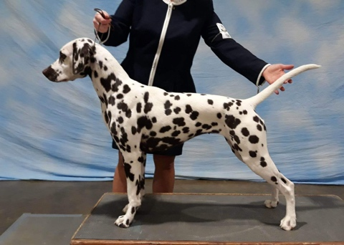  CH Pure Cntry N Iontach Here Comes The Sun CGC, TKN, ATT, BCAT(L) CHIC#189941 | GCH CH Enchanted Hart N JuJu Perfect Storm at Iontach (L) CHIC#140788 | GCHB CH JuJu’s Busy Being Fabulous CHIC#100966 | GCHB CH Onsengeltje Enough Said CHIC#81732
 |  | GCHB CH JuJu’s Busy Being Fabulous CHIC#100966 | GCH CH JuJu’s Bewitching Bailwick (L) CHIC#73742
 |  | CH Enchanted Hart So Chic Sweet Note (L) CHIC#100193 | GCH CH Pokatalica Southern Chic Bret D (L) CHIC# 87337
 |  | CH Enchanted Hart So Chic Sweet Note (L) CHIC#100193 | Ch Volunteer’s Enchanted Hart, ROM CHIC# 87738
 | CH Paisley’s Talk To Me Abby, TKN, FITB, DN, RATN, CA, SWA, SCE, ROM CHIC#111002 | BIS INT GCH Snowood Hot Rod Henry, CGC, RATN, CAT, TKN CHIC#61760 | CH CT Blackthorn Coreopsis of Patchmtn, BN, RE, OA, OJ, NF, RD CHIC#40120
 |  |  | Snowood Paisley Synergy (L) CHIC#38875
 |  | CH Atlantis The Skye’s The Limit CHIC#79097 | GCH Paisley NspirD By Broadway (L) CHIC#42287
 |  | CH Atlantis The Skye’s The Limit CHIC#79097 | CH Atlantis and Read All Over

