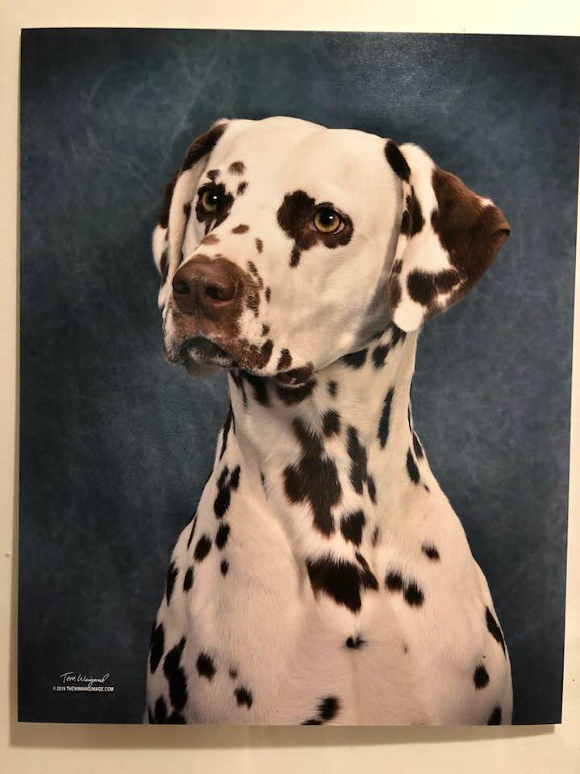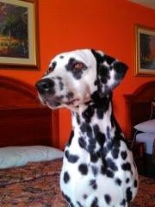
Pure Country Dalmatians is pleased to announce
Drop Kick Murphy Meets Forensic Investigator Abby in
“I’m Shipping Up To Boston” (really Texas)
Expecting Puppies June 6th (both liver and black)

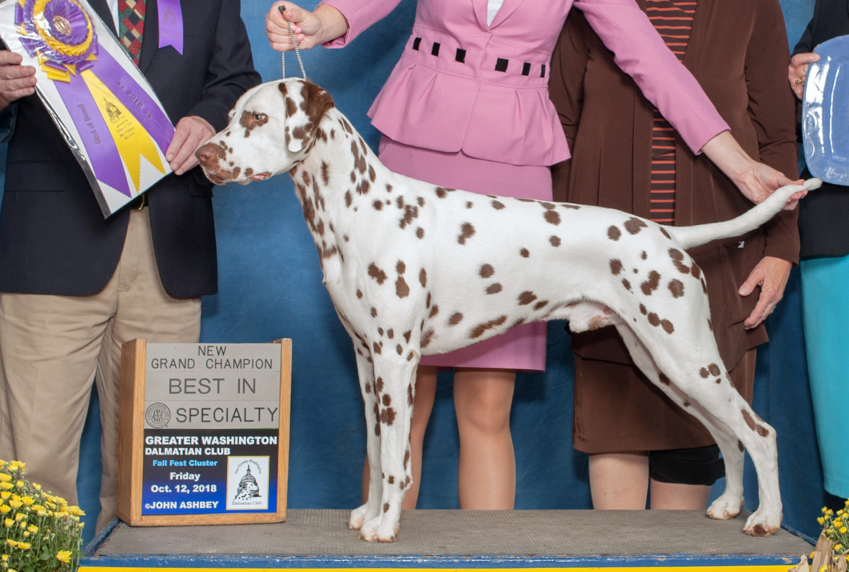  Sire  MBISS GCH CH Olympus and Enchanted Hart Drop Kick Murphy, CAX, CGC, TKN, RATI, (L) CHIC#136653 | Sire  MBISS GCHS Enchanted Hart Down N Dirty ROMX (L) CHIC#99544 | Sire  GCHB Pokatalica’s Southern Chic Bret D (L) CHIC87337 | Sire  CH Aberdeen Sawyer Brown (L) CHIC#19321
 |  | Sire  GCHB Pokatalica’s Southern Chic Bret D (L) CHIC87337 | Dam  CH Snow Hill Indy Bret D
 |  | Dam  CH Volunteer’s Enchanted Hart, ROM CHIC#87735 | Sire  CH Centurion’s Captivation of A and V CHIIC#4
 |  | Dam  CH Volunteer’s Enchanted Hart, ROM CHIC#87735 | Dam  Volunteer’s Intrigue
 | Dam  CH Liberty’s Horizon Forklore of Forbidden Fruit CHIC#109791 | Sire  GCH CH Kastle’s Go Speed Racer CHIC#67004 | Sire  GCH CH Hallmark Lincoln Lego CHIC#47418
 |  | Sire  GCH CH Kastle’s Go Speed Racer CHIC#67004 | Dam  GCH CH Kastle’s In Your Dreams
 |  | Dam  GCH CH Forklore Celtic C & C All About Me (L) | Sire  CH Tuckaway Indian Run CHIC#35004
 |  | Dam  GCH CH Forklore Celtic C & C All About Me (L) | Dam  CH Forklore Dalville Abbey Road
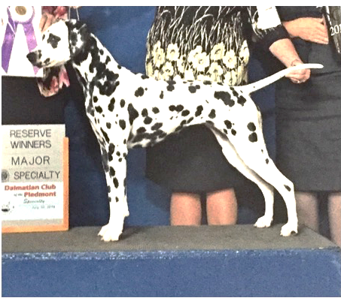  Dam  CH Paisley’s Talk To Me Abby, DN, RATN, CA, SIN, SCN, SBN CHIC#111002 | Sire  GCH CH Snowood Hot Rod Henry, CA, RATN, TKN, CGC CHIC#61700 | Sire  CH CT Blackthorn Coreopsis of Patchmtn, BN, RE, OA, OJ, NF, RD CHIC#40120 | Sire  CH Highland Flying High Again, ROM CHIC#34730
Dam
CH CT Patchmtn C Pepper N Paisley, OA, OAJ, NF, ROM CHIC#43941
 |  | Dam  CH Snowood Paisley Synergy (L) CHIC#38875 | Sire  CH North’s Never Enough Fun (L)
 |  | Dam  CH Snowood Paisley Synergy (L) CHIC#38875 | Dam  CH Paisley Snowood Family Ties (L) CGC, ROM CHIC#58350
 | Dam  CH Atlantis The Skye’s The Limit CHIC#79097 | Sire  GCH Paisley NspirD By Broadway CA, ROMX (L) CHIC#42287 | Sire  CH Monarch Snow Hill Aces High ROMX CHIC#39831
 | Dam  CH Atlantis The Skye’s The Limit CHIC#79097 | Sire  GCH Paisley NspirD By Broadway CA, ROMX (L) CHIC#42287 | Dam  CH Trailside’s Gold Mercedes (L) ROMX
 | Dam  CH Atlantis The Skye’s The Limit CHIC#79097 | Dam  CH Atlantis and Read All Over | Sire  CH Thidwick Detour, CD, RN CHIC#19328
 | Dam  CH Atlantis The Skye’s The Limit CHIC#79097 | Dam  CH Atlantis and Read All Over | Dam  CH Atlantis Blessed By Starwood

