Guinness x Lady Litter
Expected Due Date Nov 3
Both Black and Liver Puppies expected

UKC & Int’l CH & AKC GCH CH Pure Cntry’s Irish Ale of Distinction CGC, TKN, DCAT, SWN, SCA, SIA, CHIC# 171328 | MBISS GCHB CH Olympus and Enchanted Hart Drop Kick Murphy, CAX, CGC, FCAT, SIA, SEA, TKN, FITB (L) CHIC#136653 | MBISS GCHS Enchanted Hart Down N Dirty ROMX (L) CHIC#99544 | GCHB Pokatalica’s Southern Chic Bret D (L) CHIC87337
 |  | MBISS GCHS Enchanted Hart Down N Dirty ROMX (L) CHIC#99544 | CH Volunteer’s Enchanted Hart, ROM CHIC#87735
 |  | CH Liberty’s Horizon Forklore of Forbidden Fruit CHIC#109791 | GCH CH Kastle’s Go Speed Racer CHIC#67004
 |  | CH Liberty’s Horizon Forklore of Forbidden Fruit CHIC#109791 | GCH CH Forklore Celtic C & C All About Me (L)
 | UKC, INt’l & AKC CH Paisley’s Talk To Me Abby, DN, RATN, CA, SWA, SCE TKN, BCAT CHIC#111002 | GCH CH Snowood Hot Rod Henry, CA, RATN, TKN, CGC CHIC#61700 | CH CT Blackthorn Coreopsis of Patchmtn, BN, RE, OA, OJ, NF, RD CHIC#40120
 |  | GCH CH Snowood Hot Rod Henry, CA, RATN, TKN, CGC CHIC#61700 | CH Snowood Paisley Synergy (L) CHIC#38875
 |  | CH Atlantis The Skye’s The Limit CHIC#79097 | GCH Paisley NspirD By Broadway CA, ROMX (L) CHIC#42287
 |  | CH Atlantis The Skye’s The Limit CHIC#79097 | CH Atlantis and Read All Over
GCH CH Martin’s Lady On Main Street DCAT CGC TKI VHMA FITG CHIC#195576  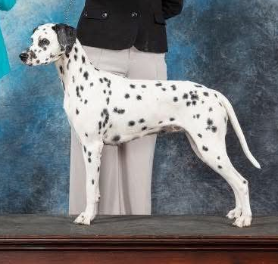 | Misouri’s Stone Crusher | Lorrie’s Grand Duke | Hog’s Maximum
 | Misouri’s Stone Crusher | Lorrie’s Grand Duke | Macy X
 | Misouri’s Stone Crusher | Killion’s Hello Dolly CHIC#179303 | Spotted Jumanji
 | Misouri’s Stone Crusher | Killion’s Hello Dolly CHIC#179303 | Kya Raye
 | Kenner’s Belle Of Delight | Windstar’s Maxamillion | Windstar’s Benjamn of Soonipi
 | Kenner’s Belle Of Delight | Windstar’s Maxamillion | CH Windstar’s Stylesetter Sandy
 | Kenner’s Belle Of Delight | RR Pebbles Delight (L) | Daimilus Bubble Balloon
 | Kenner’s Belle Of Delight | RR Pebbles Delight (L) | Spotted Dove of Peace

