Guinness X Scarlett purposed breeding

UKC & Int’l CH & AKC GCH CH Pure Cntry’s Irish Ale of Distinction CGC, TKN, DCAT, SIN, SCN, SBN, FITB CHIC# 171328 | MBISS GCHB CH Olympus and Enchanted Hart Drop Kick Murphy, CAX, CGC, TKN, RATI, DCAT(L) CHIC#136653 | MBISS GCHS Enchanted Hart Down N Dirty ROMX (L) CHIC#99544 | GCHB Pokatalica’s Southern Chic Bret D (L) CHIC87337
 |  | MBISS GCHS Enchanted Hart Down N Dirty ROMX (L) CHIC#99544 | CH Volunteer’s Enchanted Hart, ROM CHIC#87735
 |  | CH Liberty’s Horizon Forklore of Forbidden Fruit CHIC#109791 | GCH CH Kastle’s Go Speed Racer CHIC#67004
 |  | CH Liberty’s Horizon Forklore of Forbidden Fruit CHIC#109791 | GCH CH Forklore Celtic C & C All About Me (L)
 | UKC, Int’l & AKC CH Paisley’s Talk To Me Abby, DN, RATN, CA, SWN, SIA, SCA, TKN, BCAT CHIC#111002 | GCH CH Snowood Hot Rod Henry, CA, RATN, TKN, CGC CHIC#61700 | CH CT Blackthorn Coreopsis of Patchmtn, BN, RE, OA, OJ, NF, RD CHIC#40120
 |  | GCH CH Snowood Hot Rod Henry, CA, RATN, TKN, CGC CHIC#61700 | CH Snowood Paisley Synergy (L) CHIC#38875
 |  | CH Atlantis The Skye’s The Limit CHIC#79097 | GCH Paisley NspirD By Broadway CA, ROMX (L) CHIC#42287
 |  | CH Atlantis The Skye’s The Limit CHIC#79097 | CH Atlantis and Read All Over
Int’l & AKC CH Tex-Ala’s Scarlett Viv Fritz CGC, FDC CHIC#152280  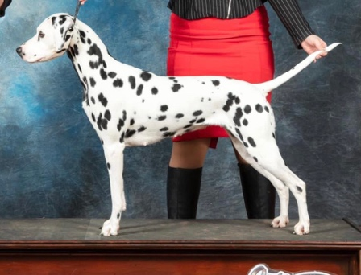 | Punch’s Votto CHIC#138378 | Punch’s Pete | Cooter III
 | Punch’s Votto CHIC#138378 | Punch’s Pete | Brackman’s Daisy
 | Punch’s Votto CHIC#138378 | Jennifer XVI | Graber’s Spotted Spot
 | Punch’s Votto CHIC#138378 | Jennifer XVI | Graber’s Spotted Misty
 | Miss Cauley- Stein CHIC#139404 | CR J CR CH Lacrima Christi Cory Casanova | Int, Fin, HR, SLO, H, RUS Spotnik’s Dare Devil
 | Miss Cauley- Stein CHIC#139404 | CR J CR CH Lacrima Christi Cory Casanova | INT, HR, STB, CH United Spots Pennsylvania
 | Miss Cauley- Stein CHIC#139404 | Rock N Roll Dove CHIC#98725 | Perfect Game’s Right On Target
 | Miss Cauley- Stein CHIC#139404 | Rock N Roll Dove CHIC#98725 | Morgan’s Rock Star (L)

